Nama : Habib Azizul Haq

Kelas : XII RPL 4

Presensi : 18

Link Github Modul 1 : <https://github.com/izzul112/Node_Pengenalan_REST_API-Modul.git>

Link Github Submission : <https://github.com/izzul112/Node_Pengenalan_REST_API-Submission.git>

**Laporan Pengenalan Rest Api NodeJS**

**Laporan Modul 1**

Import modul yang diperlukan

Endpoint Test

Hasil Endpoint Test

Endpoint /profil/nama/umur

Hasil Endpoint /profil/nama/umur

Endpoint Bujur Sangkar

Hasil Endpoint Bujur Sangkar

Menjalankan Server Pada Port 8000

**Laporan Submission Pengenalan Rest Api Node JS**

**Nomer 1**

Import modul yang diperlukan

Endpoint Kubus

Hasil Endpoint Kubus

Endpoint Balok

Hasil Endpoint Balok

Endpoint Tabung

Hasil Endpoint Tabung

Endpoint Kerucut

Hasil Endpoint Kerucut

Menjalankan Server Pada Port 8000

**Nomer 2**

Import modul yang diperlukan

Endpoint Celcius

Hasil Endpoint Celcius

Endpoint Reamur

Hasil Endpoint Reamur

Endpoint Kelvin

Hasil Endpoint Kelvin

Endpoint Fahrenheit

Hasil Endpoint Fahrenheit

Menjalankan Server Pada Port 8000

**Nomer 3**

Import modul yang diperlukan

Endpoint Decimal

Hasil Endpoint Decimal

Endpoint Biner

Hasil Endpoint Biner

Endpoint Oktal

Hasil Endpoint Oktal

Endpoint Hexa

Hasil Endpoint Hexa

Menjalankan Server Pada Port 8000

**Nomer 4**

Import modul yang diperlukan

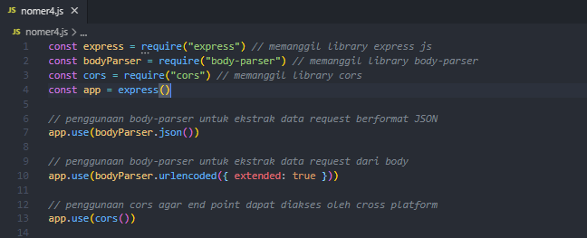

Endpoint BMI

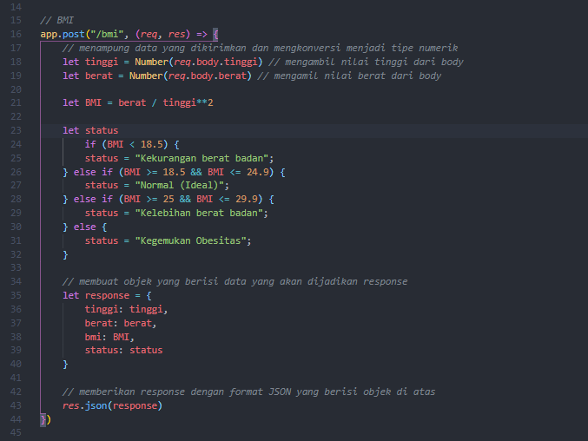

Hasil Endpoint BMI

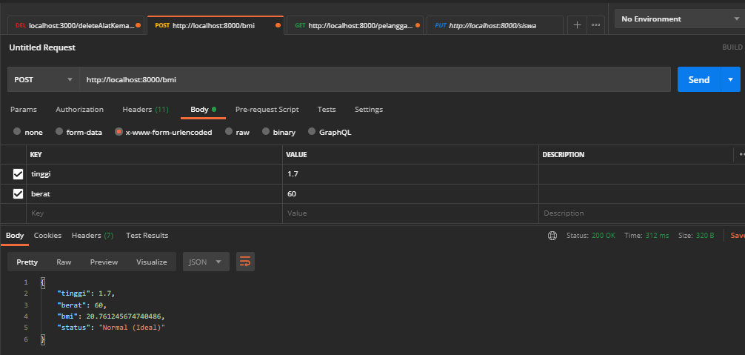

Menjalankan Server Pada Port 8000

